SESSION 1 - Introduction to Databases & Installation Topics: What
is a Database, RDBMS, SQLDB Engines (MySQL, PostgreSQL, Oracle) Installing
MySQL / SQL Server Using SQL Workbench or DB Browser Trainer Depth: Explain why SQL is the backbone of analytics. Demo: Install MySQL ? Create database
analytics_db.

Answer:

What is a Database?
- A database is an organized collection of data that allows us to store, manage, search, and update information easily.
- Instead of keeping thousands of records in Excel files, companies can store them in a database.

What is RDBMS?
- RDBMS = Relational Database Management System
- It stores data in the form of tables consisting of rows and columns.
- Examples:
  - MySQL
  - PostgreSQL
  - Oracle Database
  - Microsoft SQL Server

What is SQL?
- SQL = Structured Query Language
- SQL is used to communicate with relational databases.
- You can use SQL to:
  - Create databases
  - Create tables
  - Insert data
  - Read data
  - Update data
  - Delete data
  - Filter data
  - Sort data
  - Join multiple tables
  - Calculate totals and averages
  - Generate analytical reports

SQL Database Engines
- MySQL
  - Popular open-source relational database.
MySQL
↓
Database
↓
Tables
↓
Rows + Columns
- PostgreSQL
  - A powerful open-source relational database with many advanced features.
- Oracle
  - An enterprise-level database commonly used by large organizations.
- SQL Server
  - Microsoft's relational database system, widely used in business and enterprise environments.

Why SQL is the Backbone of Data Analytics
- As a Data Analyst, you will often work with large amounts of data stored inside databases.
- A typical analytics workflow looks like:
Database
↓
SQL
↓
Extract Data
↓
Clean / Filter Data
↓
Analyze Data
↓
Excel / Python / Power BI
↓
Reports & Insights

- Instead of manually opening an Excel file, you can use SQL
SELECT
product,
SUM(sales) AS total_sales
FROM sales
GROUP BY product;
- This is why SQL is extremely important for Data Analysts.

Installation
- Starting with MySQL + MySQL XAMPP
Install XAMPP
↓
Open XAMPP Control Panel
↓
Start MySQL
↓
Open phpMyAdmin
↓
Create analytics_db
↓
Create customers table
↓
Insert data
↓
SELECT * FROM customers

Demo
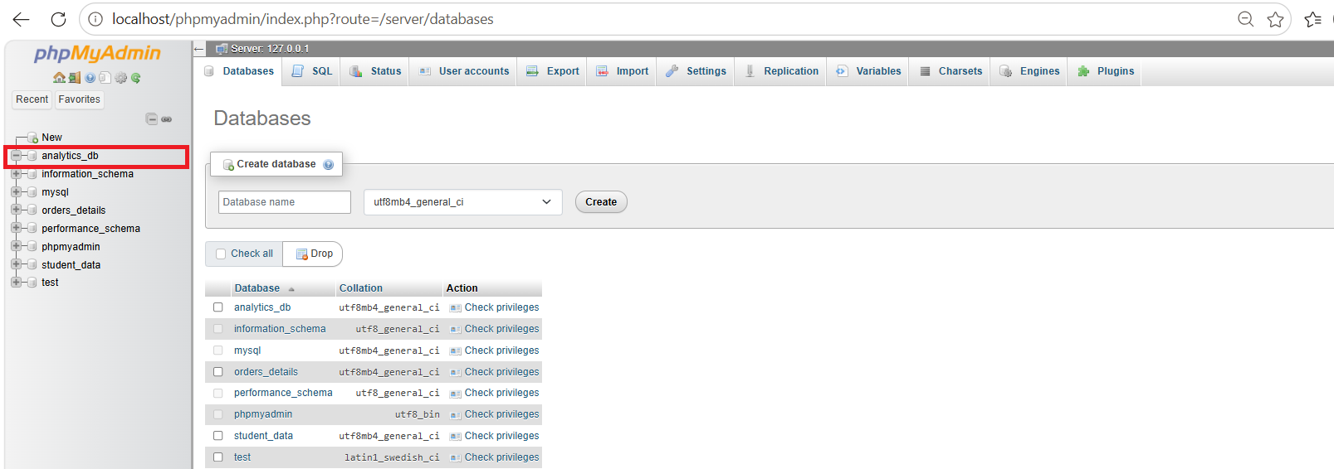
CREATE DATABASE analytics_db

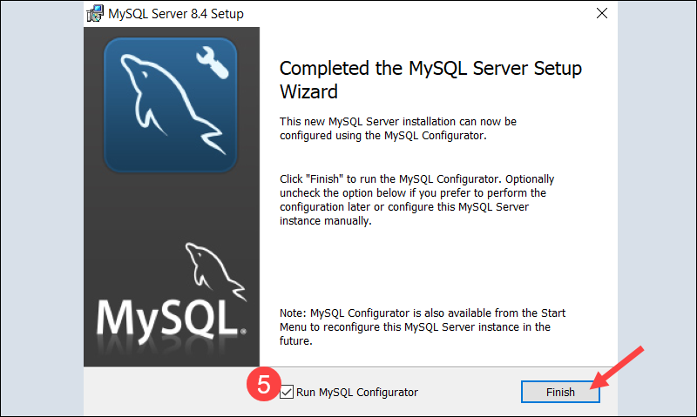
Tasks_01

Tasks_02
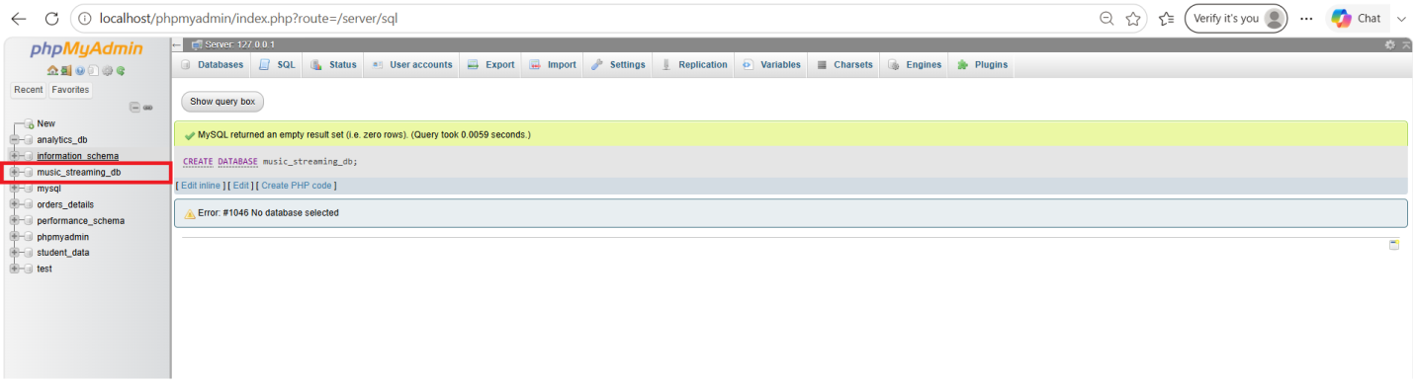
CREATE DATABASE music_streaming_db.

Tasks_03
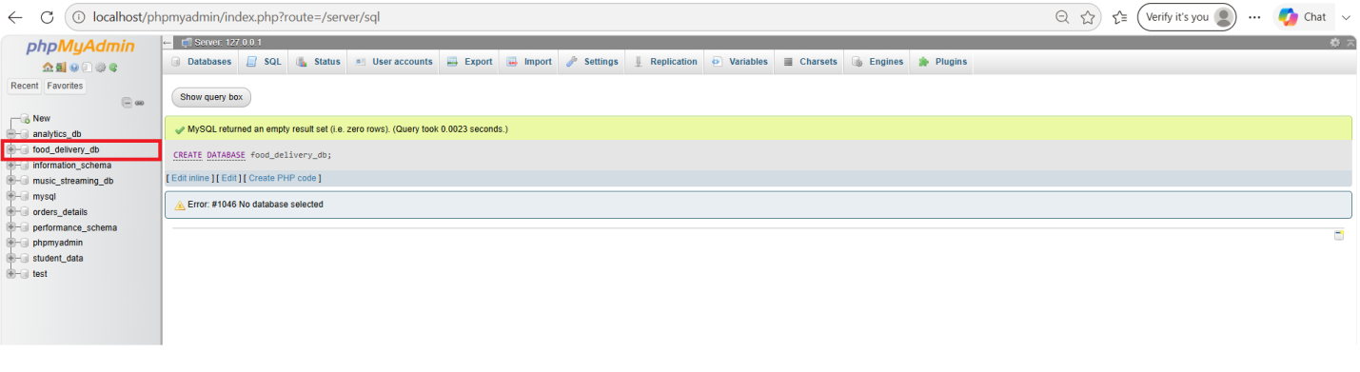
CREATE DATABASE food_delivery_db.

Tasks_04

Differences between MySQL and PostgreSQL

Features | MySQL | PostgreSQL
Complexity | Generally easier for beginners and common web applications. | More feature-rich and suited to complex database requirements.
Advanced features | Strong support for standard relational database operations and common web workloads. | Strong support for advanced SQL, complex queries, custom data types, and extensions.
Common use cases | Popular for websites, e-commerce, and applications where straightforward relational data storage is needed. | Often chosen for complex analytics, geospatial applications, and systems requiring advanced database capabilities.

- Examples of companies/apps
  - MySQL: Meta (Facebook) has historically used MySQL extensively for its application data infrastructure.
  - PostgreSQL: Instagram uses PostgreSQL as a major part of its backend data infrastructure.
- Note: Both are powerful relational databases, and the choice depends on the application's requirements rather than one being universally "better."

